
Mehran University of Engineering & Technology Jamshoro
Subject: Electronic Instrumentation Systems
Assignment

Smart Posture and Angle Monitoring System Using MPU6050 Sensor and Machine Learning

Submitted by
DANIYAL 22ES077

1. Introduction
In recent years, smart health monitoring systems have gained significant importance due to increasing awareness of posture-related health issues. Improper posture can lead to long-term problems such as spinal misalignment, back pain, and reduced productivity.
To address this issue, a posture monitoring system is designed using the MPU6050 sensor, which measures motion and orientation. The system is enhanced using Machine Learning techniques to classify different human postures automatically. This integration improves system intelligence compared to traditional rule-based approaches.
2. Objectives
The main objectives of this project are:
- To acquire motion data using MPU6050 sensor
- To preprocess and analyze sensor data
- To apply Machine Learning for posture classification
- To evaluate system performance using accuracy metrics
- To develop an intelligent posture detection system

3. Instrumentation System Description
3.1 Components Used
- MPU6050 (Accelerometer + Gyroscope)
- Arduino Microcontroller
- Power Supply
- Connecting Wires

3.2 Working Principle
The MPU6050 sensor measures:
- Linear acceleration (Ax, Ay, Az)
- Angular velocity (Gx, Gy, Gz)
These values vary depending on body orientation and movement. The collected data is processed and used as input to a Machine Learning model for posture classification.

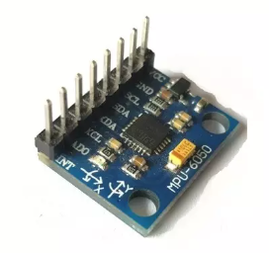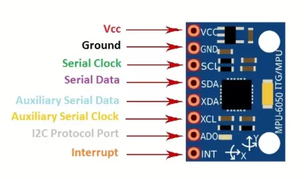
Figure 1: MPU6050 Sensor Module

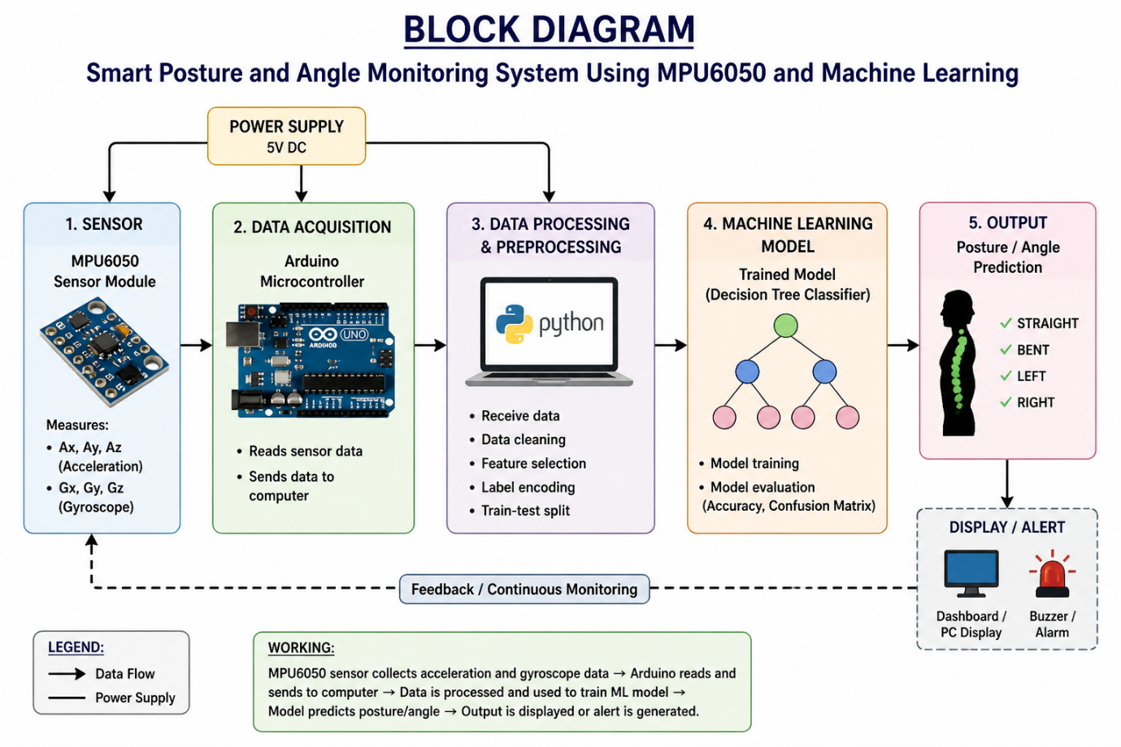
Figure 2: System Block Diagram

4. Data Collection Method
4.1 Dataset Description
The dataset includes:
- Ax, Ay, Az (Acceleration values)
- Gx, Gy, Gz (Gyroscope values)
- Posture (Output label)

4.2 Posture Classes
- STRAIGHT
- BENT
- LEFT
- RIGHT

4.3 Dataset Size
- Total samples: 600

 | Ax | Ay | Az | Gx | Gy | Gz | Posture
0 | -2.27512 | 0.65463 | 9.189544 | 0.684225 | -0.458413 | -0.06207 | LEFT
1 | -1.86048 | 0.803155 | 8.767649 | -0.26259 | -0.28569 | -0.46204 | LEFT
2 | 0.524358 | 1.741376 | 8.074478 | -0.08193 | -0.738165 | 0.74349 | BENT
3 | 1.727809 | 0.533277 | 8.539603 | 0.187849 | -0.300319 | -0.14585 | RIGHT
4 | 2.389596 | 0.169671 | 9.452091 | 0.186559 | -0.193236 | -0.57939 | RIGHT
Sample Dataset of starting 5 rows
5. Data Preprocessing
The dataset was processed using Python.
Steps Performed
- Data loading using pandas
- Checking missing values
- Encoding categorical labels
- Data visualization

5.1 Label Encoding
STRAIGHT = 0
BENT = 1
LEFT = 2
RIGHT = 3

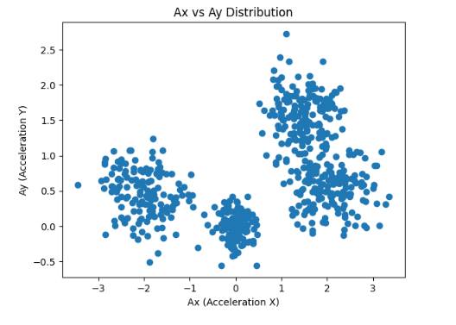
Figure 3: Ax vs Ay Scatter Plot

This graph shows the relationship between acceleration values in X and Y directions, helping visualize posture distribution.
6. Machine Learning Method
6.1 Model Used
Decision Tree Classifier

6.2 Reason for Selection
- Simple and interpretable
- Suitable for classification problems
- Handles non-linear data effectively

6.3 Model Inputs and Outputs
Inputs: Ax, Ay, Az, Gx, Gy, Gz
Output: Posture class

6.4 Training Process
- Dataset split into 80% training and 20% testing
- Model trained using Decision Tree algorithm

7. Results and Analysis
7.1 Model Accuracy
The performance of the model is evaluated using accuracy.
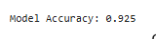
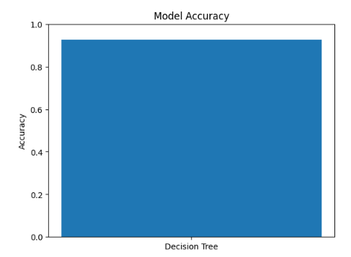
Figure 5: Model Accuracy Graph

This graph represents the accuracy of the Decision Tree model.
7.2 Confusion Matrix
The confusion matrix shows correct and incorrect predictions.
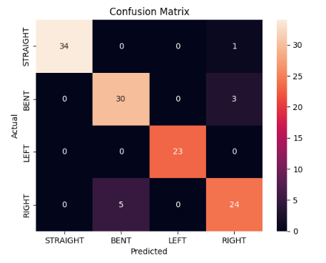
Figure 6: Confusion Matrix Heatmap
The diagonal values represent correct predictions, indicating good model performance.

7.3 Observations
- High classification accuracy achieved
- Most predictions are correct
- Model performs well for all posture classes

8. Intelligent System Feature
The system provides intelligent features such as:
- Automatic posture classification
- Real-time prediction capability
- Improved decision-making

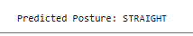
Figure 7: Model Prediction Output

9. System Integration
Traditional System
- Uses fixed threshold-based logic
ML-Based System
- Learns from data
- Adapts to variations
- Provides better accuracy

10. Conclusion
A smart posture monitoring system was successfully developed using MPU6050 sensor and Machine Learning. The Decision Tree model effectively classifies different postures based on sensor data.
The integration of ML enhances system intelligence and demonstrates the application of data-driven techniques in electronic instrumentation systems.

11 Code
11.1 Python Code

# ============================================
# 1. IMPORT LIBRARIES
# ============================================
import pandas as pd
import matplotlib.pyplot as plt
import seaborn as sns
# ============================================
# 2. LOAD DATASET
# ============================================
data = pd.read_csv("mpu6050_dataset.csv")

print("First 5 Rows:")
print(data.head())

# ============================================
# 3. DATA INFORMATION & CLEANING
# ============================================
print("\nDataset Info:")
print(data.info())

print("\nMissing Values:")
print(data.isnull().sum())

# ============================================
# 4. DATA PREPROCESSING (ENCODING LABELS)
# ============================================
data['Posture_encoded'] = data['Posture'].map({
'STRAIGHT': 0,
'BENT': 1,
'LEFT': 2,
'RIGHT': 3
})

print("\nEncoded Data Sample:")
print(data.head())

# ============================================
# 5. DATA VISUALIZATION
# ============================================
plt.figure()
plt.scatter(data['Ax'], data['Ay'])
plt.xlabel("Ax (Acceleration X)")
plt.ylabel("Ay (Acceleration Y)")
plt.title("Ax vs Ay Distribution")
plt.show()

# ============================================
# 6. PREPARE DATA FOR MACHINE LEARNING
# ============================================
from sklearn.model_selection import train_test_split

X = data[['Ax','Ay','Az','Gx','Gy','Gz']] # Input features
y = data['Posture_encoded'] # Output label

X_train, X_test, y_train, y_test = train_test_split(
X, y, test_size=0.2
)

# ============================================
# 7. TRAIN MACHINE LEARNING MODEL
# ============================================
from sklearn.tree import DecisionTreeClassifier

model = DecisionTreeClassifier()
model.fit(X_train, y_train)

print("\nModel trained successfully!")

# ============================================
# 8. MAKE PREDICTIONS
# ============================================
y_pred = model.predict(X_test)

# ============================================
# 9. MODEL ACCURACY
# ============================================
from sklearn.metrics import accuracy_score

accuracy = accuracy_score(y_test, y_pred)
print("\nModel Accuracy:", accuracy)

# ============================================
# 10. CONFUSION MATRIX (GRAPH)
# ============================================
from sklearn.metrics import confusion_matrix

cm = confusion_matrix(y_test, y_pred)

plt.figure()
sns.heatmap(cm, annot=True, fmt='d',
xticklabels=['STRAIGHT','BENT','LEFT','RIGHT'],
yticklabels=['STRAIGHT','BENT','LEFT','RIGHT'])
plt.xlabel("Predicted")
plt.ylabel("Actual")
plt.title("Confusion Matrix")
plt.show()

# ============================================
# 11. ACCURACY GRAPH
# ============================================
plt.figure()
plt.bar(["Decision Tree"], [accuracy])
plt.ylim(0,1)
plt.title("Model Accuracy")
plt.ylabel("Accuracy")
plt.show()

# ============================================
# 12. TEST WITH NEW INPUT (SMART FEATURE)
# ============================================
sample = pd.DataFrame([[0.1, 0.2, 9.7, 0.1, 0.2, 0.1]],
columns=['Ax','Ay','Az','Gx','Gy','Gz'])

prediction = model.predict(sample)

map_label = {
0: "STRAIGHT",
1: "BENT",
2: "LEFT",
3: "RIGHT"
}

print("\nPredicted Posture:", map_label[prediction[0]])

12.References

- Arduino IDE Documentation.
https://www.arduino.cc/en/Guide
- Scikit-learn Documentation.
https://scikit-learn.org/stable/
- MPU6050 Datasheet.
https://invensense.tdk.com/products/motion-tracking/6-axis/mpu-6050/
- Python Documentation.
https://docs.python.org/3/

